Assignment #3 - Advertisement Webpage

Esther Wason LIB2024 - Internet Applications

Dr. Huthaifa Abderahman

2023-03-20

Table of Contents

List Of Elements and Introduction 3

Project Summary And Eplanation of Codes 4

Conclusion/SEO 4

References 5

List Of Elements Used and CSS

<!DOCTYPE> This tag defines the type of document being made.

<html> This tag defines the root of the document.

<head> This tag contains metadata.

<meta> This tag describes metadata in the document or information about the data.

<title> This tag creates a title for the document.

<link> This tag connects the document to an external resource.

<body> This tag defines everything that is contained in the body of a document.

<h1> This tag defines a heading.

<div> This tag defines a section or “division” of a document.

<p> This tag defines a paragraph.

<img> This tag defines an image.

}

@keyframes shake {

<p> </p>

display: block;

Margin-left: auto;

Margin- right: auto;

Width: 25%;

Pointer-events;

.flier > * {

animation: fly 50s linear infinite;

pointer-events: none !important;

top: 0;

left: 0;

transform: translateX(-80%) translateY(-80%) rotateZ(0);

position: fixed;

animation-delay: 1s;

z-index: ;

}

Introduction And Project Summary

For this assignment, I created a web page that featured two animations as per the assignment requirements. I decided to focus more on creating the animations as well as adding a large text. I was able to successfully format my webpage to my desire and have it fit under a cohesive theme. All CSS code is in **BLUE**, All **HTML** code is in RED

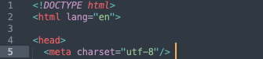

* The first section of the code contains the <doctype> and <html> elements. These elements declare the type of document as well as the language of the document. The <head> section contains metadata, including the <meta>, <title>, and <link> elements. The charset attribute declares the type of characters used in the webpage, the <title> element declares the webpage title or the text on the tab, and the <link> attributes are used to add the stylesheets and the icon or favicon on the tab.



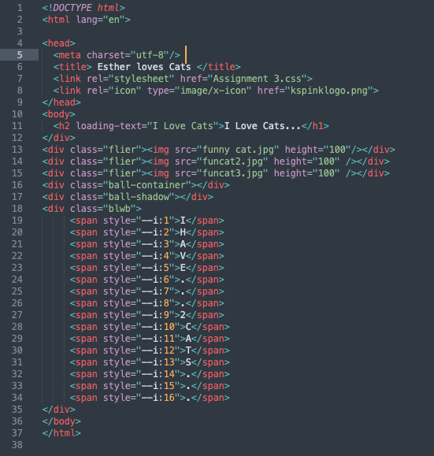The <body> section starts with the heading to ensure users know what the webpage is about. I separated the watermark into three sections by giving the <div> elements class attributes.

The last section of my CSS file, served the same purpose as the heading background within the website. I was able to change all the aestheic elements surrounding the text. The HTML section was just the physical text before it was edited to fit the format of the website. As well, I use closed out the body and html tags completely to end the webpage.

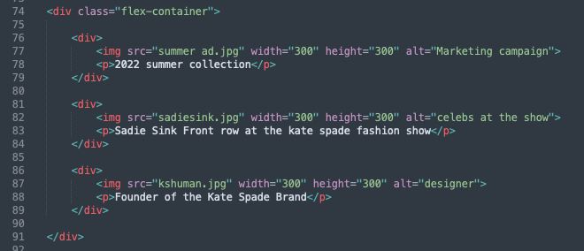  
  
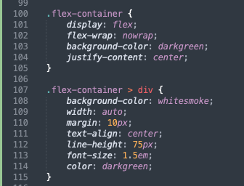 For the flexbox, I made 2 containers with the same class for easy styling. I made 2 containers to ensure the images were spaced in a way that I liked. I also made sure all of the images were the same size to avoid any stretching of the flexbox. I styled the containers by adding the class “flex-container” and using the >div attribute to style the individual boxes differently than the background of the container.  
Conclusion  
This webpage effectively demonstrates the assignment requirements while ensuring ease the user which would be me in this context. In conclusion, this assignment was fun to play around with and use fun CSS. I had the opportunity to try out new tags and add some colour coordination within my webpage which was nice. I thoroughly enjoyed the animations and think it adds a lot to my webpage. Using SEO standards, my webpage would be a good choice for someone browsing because my webpage has a uniform theme and fun elements that pop up on the page. It is interactive with a user and the title on my webpage would also be useful for anyone searching about animations in general. The text on my page is easy to read for anyone and everyone because it pops out on the page, especially with the contrasting background. The alt text is also helpful for those that may need it.

References

Juviler, J. (2022, May 16). 24 creative and unique CSS animation examples to inspire your own. HubSpot Blog. Retrieved March 16, 2023, from https://blog.hubspot.com/website/css-animation-examples

W3Schools free online web tutorials. W3Schools Online Web Tutorials. (n.d.). Retrieved March 16, 2023, from https://www.w3schools.com/

CSS Tutorial. CSS tutorial. (n.d.). Retrieved February 23, 2023, from <https://www.w3schools.com/css/default.asp>

Paul.hebert@consultant.cloudinary.com. (2022, November 2). CSS image effects: Five examples and a quick animation guide. Cloudinary Blog. Retrieved March 16, 2023, from https://cloudinary.com/blog/css_image_effects_five_simple_examples_and_a_quick_animation_guide